H.T No
Regulations:
A20

Sreenidhi Institute of Science and Technology
(An Autonomous Institution)
Code No:8FC02 Date: 13-Sept-2021 (FN)

B.Tech I-Year II- Semester External Examination, Sept-2021 (Regular)
PYTHON PROGRAMMING (CSE and IT)

Time: 3 Hours Max.Marks:70

Note: a) No additional answer sheets will be provided.
b) All sub-parts of a question must be answered at one place only, otherwise it will not be valued.
c) Missing data can be assumed suitably.

ANSWER ANY 5 OUT OF 8 QUESTIONS. EACH QUESTION CARRIES 14 MARKS.

Bloom's Cognitive Levels of Learning (BCLL)

Remember | L1 | Apply | L3 | Evaluate | L5
Understand | L2 | Analyze | L4 | Create | L6

 |  |  | BCLL | CO(s) | Marks
1. | a) | Explain the basic data types available in Python with examples. | L2 | CO1 | [7M]
 | b) | Write Python Program to reverse a number and also find the Sum of digits in the reversed number. Prompt the user for input. | L3 | CO1 | [7M]
2. | a) | Explain the use of join() and split() string methods with examples. Describe why strings are immutable with an example. | L2 | CO2 | [7M]
 | b) | Discuss the relation between tuples and lists, tuples and dictionaries in detail. | L2 | CO2 | [7M]
3. | a) | How to handle an exception using try except block? Explain with the help of a program. | L3 | CO3 | [7M]
 | b) | What are the two ways of importing a module? Which one is more beneficial? Explain | L2 | CO3 | [7M]
4. | a) | How to implement method overriding in Python? Explain. | L3 | CO4 | [7M]
 | b) | List the features and explain about different Object Oriented features supported by Python. | L2 | CO4 | [7M]
5. | a) | Write a Python Program to copy contents of one file to a different file. | L3 | CO5 | [7M]
 | b) | Consider the file structure given below. Write Python program to delete all the files and subdirectories from the Extinct_Animals Directory.  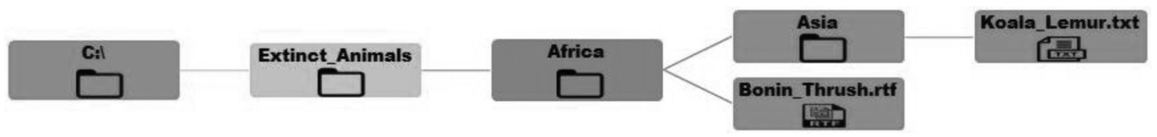 | L3 | CO5 | [7M]
6. | a) | Write a NumPy program to create a 5x5 array with random values and find the minimum and maximum values. | L3 | CO6 | [7M]
 | b) | Write a Python GUI program to add a button in your application using Tkinter module. | L3 | CO6 | [7M]
7. | a) | Explain the control structures in Python with examples. | L2 | CO1 | [5M]
 | b) | Explain the following list methods with an example. i. append() ii. extend() iii. insert() | L2 | CO2 | [5M]
 | c) | Discuss with an example exceptions with arguments in Python. | L2 | CO3 | [4M]
8. | a) | Explain how to implement inheritance in Python. | L2 | CO4 | [5M]
 | b) | Write a Python program to check whether a file path is a file or a directory. | L3 | CO5 | [5M]
 | c) | Explain about GUI programming in python. | L2 | CO6 | [4M]
- 00 -- 00 –

